SKILL-9
- To Change Directories, Validate Paths, Update Working Directory, Handle Errors, Maintain Previous Directory, Test Navigation.
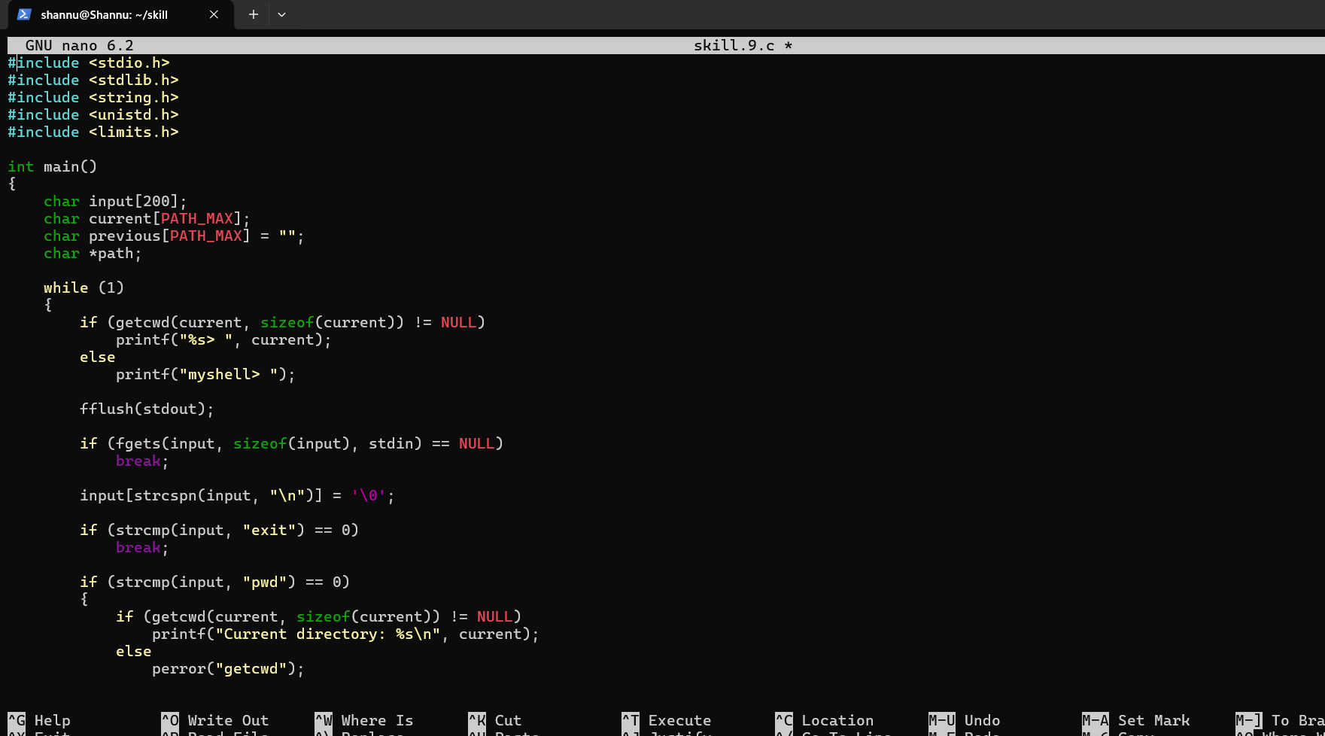
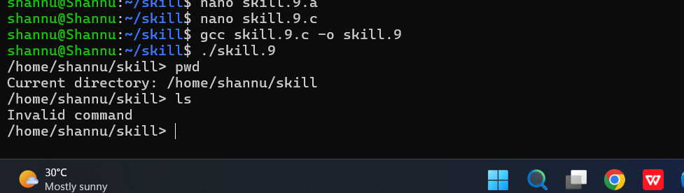

To Identify Built-ins, Create Dispatch Table, Execute In-Process Commands, Handle Invalid Commands, Maintain State, Test Dispatch Logic.
